Data Transformation, Modeling & Visualization with Power BI”

Data Cleaning & Transformation

1. number (Station ID)
Problems
- May contain duplicates
- Needs consistent datatype
Cleaning Steps
- Change Type → Whole Number
- Remove duplicates:
  - Home → Remove Rows → Remove Duplicates
3. Column Rename
- Number → Station ID
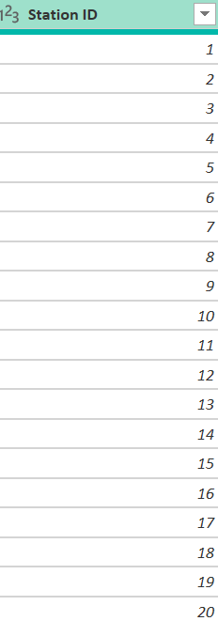

2.name
Cleaning Steps
- Split Column → By Delimiter ,
- Rename columns: Station Number , Station Name
- Change Type → Text
- Trim spaces

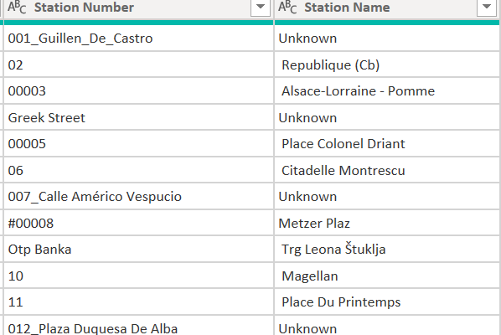

3. address
Problems
- Null values
- ALL CAPS
- Extra spaces
Cleaning Steps
- Replace Null → "Unknown"
- Transform → Trim
- Transform → Clean
- Capitalize Each Word
- Rename Column → Address

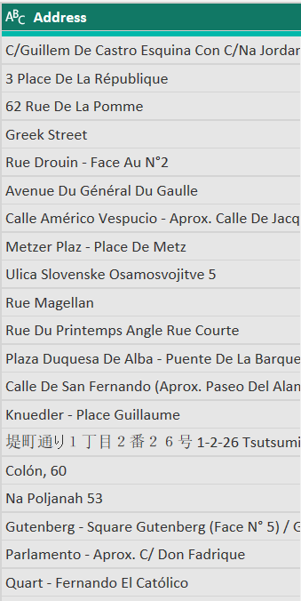

4. position
(Current format = "latitude, longitude")
Cleaning Steps
- Split Column → By Delimiter ,
- Rename columns → Latitude , Longitude
- Change Type → Decimal Number
- Trim spaces
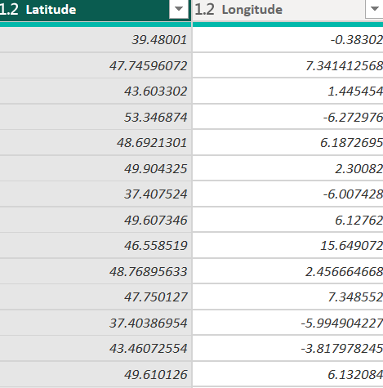
5. banking
Problems
Boolean True/False
Cleaning
Transform → Replace Values
True → Yes
False → No
Rename: Banking Available
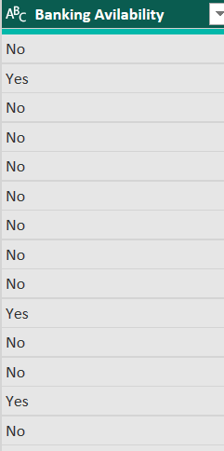
6. bonus
Problems
Boolean True/False
Cleaning
Transform → Replace Values
True → Yes
False → No
Rename: Bonus Station
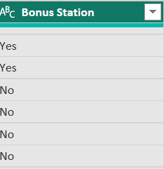

7. status
Problems
Uppercase text
Cleaning
Transform → Format → Capitalize Each Word
Rename: Station Status

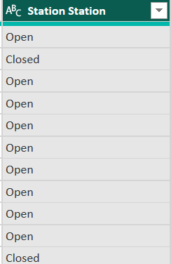
8. Contract Name (city information)
Cleaning
- Rename column: City
- Capitalize Each Word
- Trim spaces

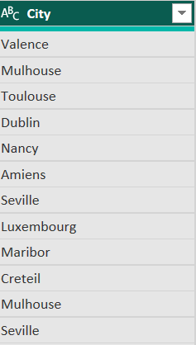

Bike Stands
Cleaning
- Change Type → Whole Number
- Replace null → 0
Rename: Total Bike Stands
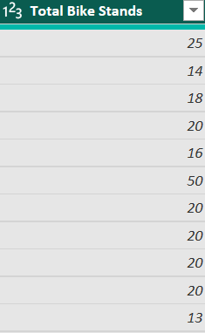

10. Available Bike Stands
Cleaning
- Change Type → Whole Number
- Replace null → 0
Rename: Available Bike Stands

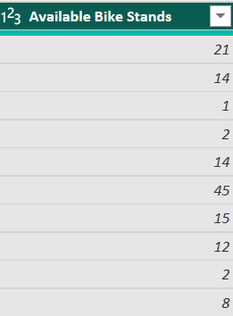

11. Available Bikes
Cleaning
- Change Type → Whole Number
- Replace null → 0
Rename: Available Bikes

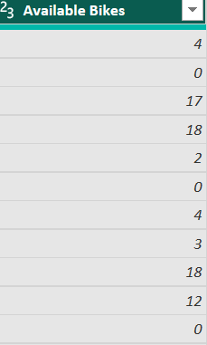
12. Last Update
Problems
ISO datetime format
Cleaning
- Change Type → Date/Time
- Extract:
  - Date
Rename: Last Update
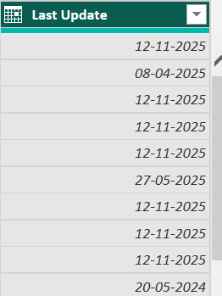

Data Modelling

Define Relationships (Model View)
Fact → Dimension
- Fact Station Status[Fact_ID]
- Dim Station [Dim_ID]
- One-to-Many (1:*)

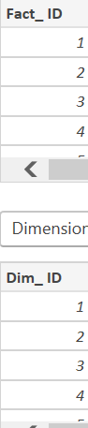
Fact → Dimention
- Station Status[status]
- Station Status[status]
- One-to-Many

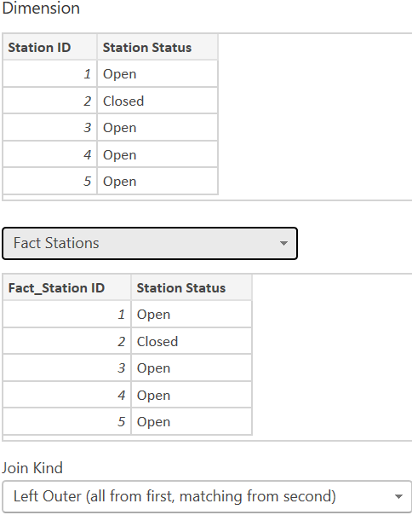

DAX Calculations and Measures

Calculations
Station Utilization %
Create in Data View → New Column
DAX formula:
Utilization % = DIVIDE(Feuil1[Total Bike Stands],Feuil1[Available Bikes])
Findings: Shows how full each station
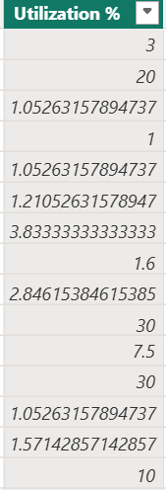
Capacity Status
Create in Data View → New Column
DAX formula:
Capacity Status = IF([Available Bikes] = 0, "Empty", IF([Available Bikes] < ([Total Bike Stands]* 0.3), "Low","Healthy"))
Findings: Helps identify empty stations.

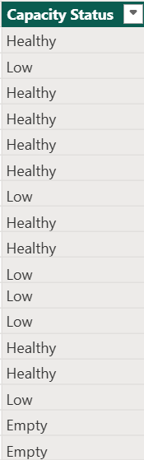
Station Active
Create in Data View → New Column
DAX formula:
Is Active =IF([Station Status] = "Open", 1, 0)
Findings: Helps in finding weather the station is active or inactive.
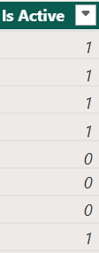
City and Station Name
Create in Data View → New Column
DAX formula:
City Station = [City] & " - " & [Station Name]
Findings: Helps in finding in which city the station is located.

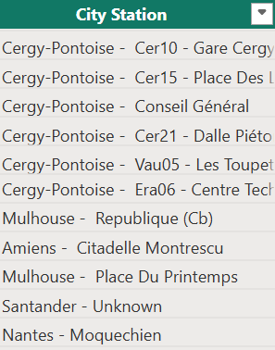

Update Recency Category
Create in Data View → New Column
DAX formula:
Update Freshness = IF(DATEDIFF([Last Update], NOW(), HOUR) <= 1,"Recent","Old Update")
Findings: Helps in finding weather the records in the station is up to date.
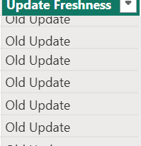

DAX Measures
Total Bikes
Create in Modeling → New Measure
DAX Measure Formula: Total Bikes = SUM('Feuil1'[Available Bikes])
Findings: Helps in finding total Number of bikes
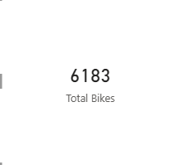

Total Bike Stands
Create in Modeling → New Measure
DAX Measure Formula: Total Stands = SUM(Feuil1[Total Bike Stands])
Findings: Helps in finding total Number of bikes stands
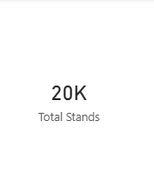

Total Stations
Create in Modeling → New Measure
DAX Measure Formula: Total Stations =DISTINCTCOUNT(Feuil1[Station ID])
Findings: Helps in finding total Number of Stations
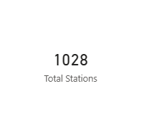

Active Stations
Create in Modeling → New Measure
DAX Measure Formula: Active Stations = CALCULATE(COUNT('Feuil1'[Station ID]),
'Feuil1'[Station Status] = "Open")
Findings: Helps in finding total Number of Active Stations
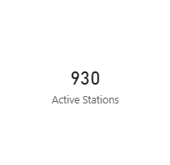
Empty Stations
Create in Modeling → New Measure
DAX Measure Formula: Empty Stations = CALCULATE( COUNT('Feuil1'[Station ID]),'Feuil1'[Available Bikes] = 0)
Findings: Helps in finding total Number of Empty Stations

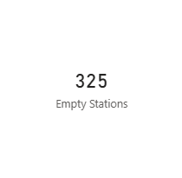

Aggregations (Performance Metrics)

Average Bikes per Station
Create in Modeling → New Measure
DAX Measure Formula: Avg Bikes per Station = AVERAGE('Feuil1'[Available Bikes])
Findings: Helps in finding total Number of Average Number of bikes available per station

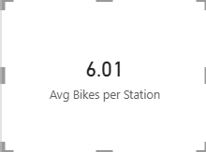

Average Station Capacity
Create in Modeling → New Measure
DAX Measure Formula: Avg Station Capacity = AVERAGE(Feuil1[Total Bike Stands])
Findings: Helps in finding total capacity of the each station

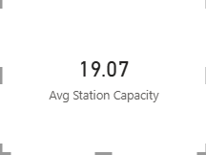

Bikes by City
Create in Modeling → New Measure
DAX Measure Formula: Total Bikes by City = SUM(Feuil1[Available Bikes])
Findings: Helps in finding total number of Bikes in each city

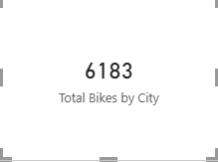

Ratios Calculation

Network Utilization %
Create in Modeling → New Measure
DAX Measure Formula: Utilization % = DIVIDE(Feuil1[Total Bike Stands],Feuil1[Available Bikes])
Findings: Helps in finding total number of networked station

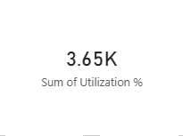

Empty Station %
Create in Modeling → New Measure
DAX Measure Formula: Empty Station % = DIVIDE([Empty Stations], [Total Stations])
Findings: Helps in finding percentage of Empty station.

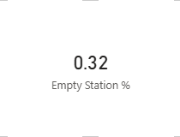

Active Station %
Create in Modeling → New Measure
DAX Measure Formula: Active Station % = DIVIDE([Active Stations], [Total Stations])
Findings: Helps in finding percentage of Active station.

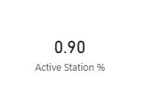

Banking Station %
Create in Modeling → New Measure
DAX Measure Formula: Banking % = DIVIDE(CALCULATE(COUNT('Feuil1'[Station ID]),'Feuil1'[Banking Avilability] = "Yes"),[Total Stations])
Findings: Helps in finding percentage of Active station.
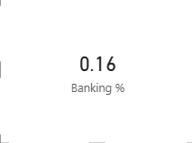
Data Visualization

VISUAL 1- MAP (Station-Level View)
Used Map Visual
Bubble size = available bikes
Colour = OPEN / CLOSED
Insight: shows station details
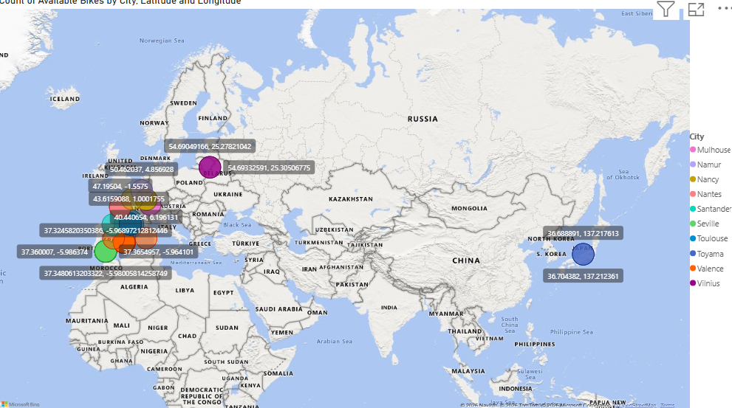

VISUAL 2 - Available Bikes by City
Used Clustered Column Chart
Insight:This shows city-wise available bikes and OPEN/CLOSED breakdown.

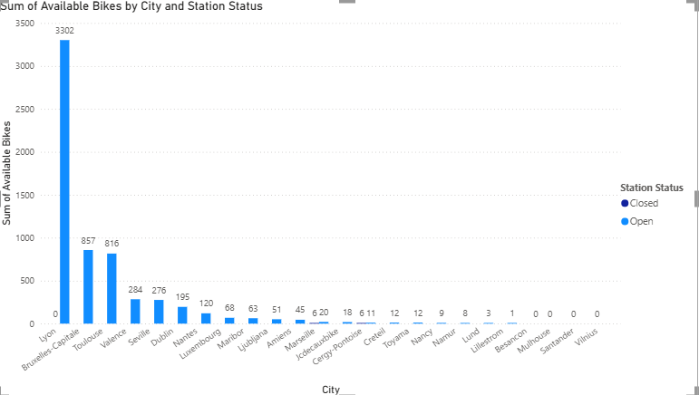

VISUAL 3 - Capacity vs Availability Comparison
Used Stacked Column Chart
Insight:This compares total capacity vs available bikes per city.
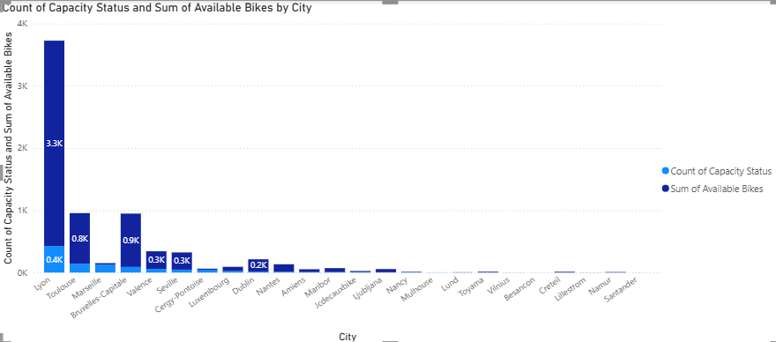
VISUAL 4 - Station Status Distribution
Used Donut Chart
Insight:Shows % of OPEN vs CLOSED stations.
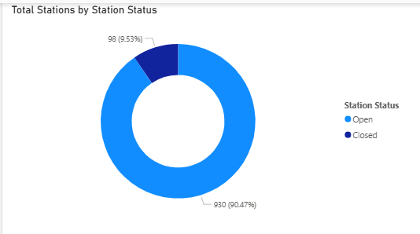

VISUAL 5- Banking Facility Analysis
Used Pie Chart
Insight:Shows stations with card payment facility.

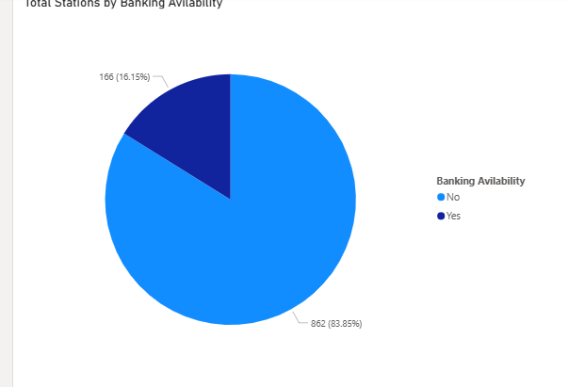

VISUAL 6 — Top 10 Stations by Available Bikes
Used Bar Chart
Insight:This gives best-performing stations.

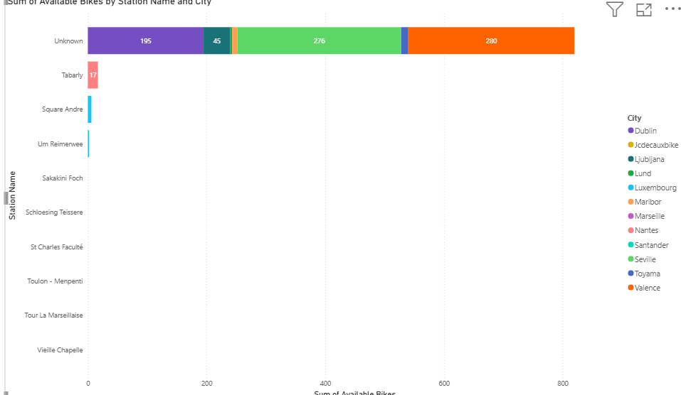

VISUAL 7- Last Update Monitoring
Used Line Chart
Insight:Shows availability trend over time.
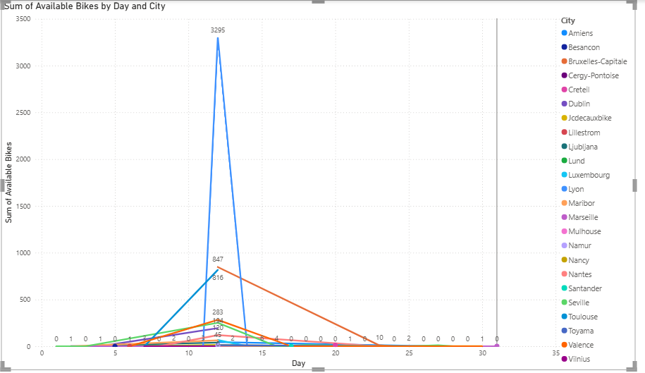
FINAL DASHBOARD
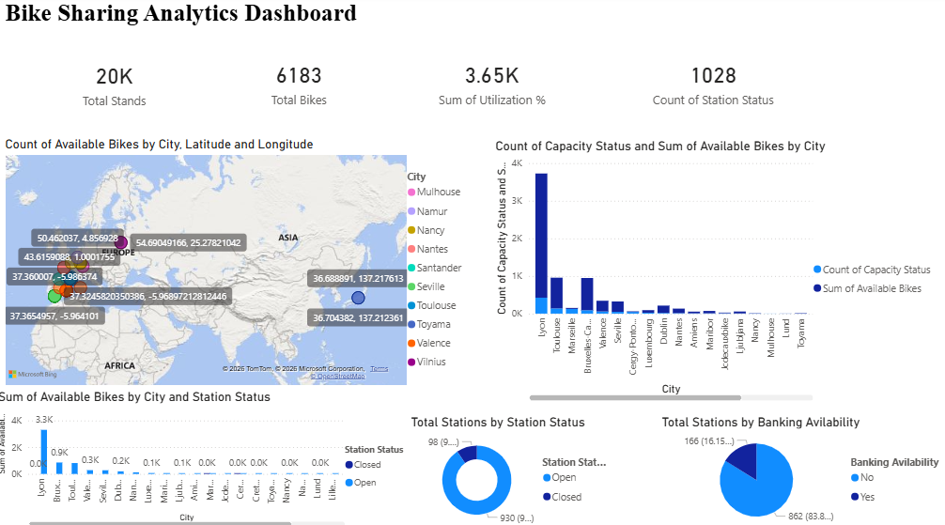

Dashboard Description
Row 1:
KPI Cards
Row 2:
Left → Map
Right → Capacity vs Availability
Row 3:
Left → Bikes by City
Middle → Status Donut
Right → Banking Pie

Summary,Insights and Recommendations

Summary of Findings
1. Overall Network Performance
- Total stations represent a well-distributed urban bike network.
- Most stations are operational (OPEN), ensuring high service availability.
- Total capacity is significantly higher than available bikes at certain times, indicating varying demand levels.

2. Geographic Distribution
- Bike stations are spread across multiple cities (City).
- Some cities have higher station density and availability.
- Map visualization shows clusters of high and low availability zones.

3. Availability & Utilization
- Utilization % indicates that not all capacity is optimally used.
- Certain stations frequently show low bike availability.
- A small number of stations contribute disproportionately to total availability.

4. Banking & Bonus Facilities
- Not all stations support banking (card payment).
- Bonus-enabled stations are limited.
- Banking-enabled stations show better usability and accessibility.

5. Operational Monitoring
- OPEN vs CLOSED analysis shows operational reliability.
- Few CLOSED stations may impact customer experience in certain areas.

Key Insights

Insight 1: Uneven Distribution of Bikes
Some cities have:
- High capacity but lower availability
- Potential imbalance in bike redistribution
Indicates need for demand-based allocation.

Insight 2: High-Performing Stations
- Top 10 stations contribute significantly to total available bikes.
These are high-demand or well-managed stations.

Insight 3: Low Availability Risk Zones
Stations with:
- 0 bikes
- Less than 5 bikes
These stations create customer dissatisfaction risk.

Insight 4: Payment Accessibility Gap
Stations without banking facilities:
- May limit user adoption
- Reduce convenience for tourists or new users

Insight 5: Capacity Underutilization
In some cities:
- Total capacity >> available bikes
- Infrastructure investment not fully optimized

Business Recommendations

1. Implement Smart Redistribution Strategy
- Monitor low-availability stations
- Redistribute bikes during peak hours
- Use predictive analytics for demand forecasting

2. Expand Banking Facilities
- Upgrade non-banking stations
- Improve digital payment support
- Increase customer adoption rate

3. Optimize Capacity Allocation
- Reduce overcapacity in low-demand areas
- Increase capacity in high-demand zones
- Adjust based on city-level usage pattern

4. Focus on Closed Stations
- Investigate reasons for station closures
- Improve maintenance scheduling
- Ensure 95%+ operational uptime

5. Introduce Performance Monitoring KPIs
Track regularly:
- Utilization %
- Availability Rate
- Station Downtime %
- Demand per City

